**DAILY ONLINE ACTIVITIES SUMMARY**

|  |  |  |  |  |  |  |  |
| --- | --- | --- | --- | --- | --- | --- | --- |
| **Date:** | **31/05/2020** | | | | **Name:** | **Imran Khan** | |
| **Sem & Sec** | **8th A** | | | | **USN:** | **4AL16CS040** | |
| **Online Test Summary** | | | | | | | |
| **Subject** | | **IOT** | | | | | |
| **Max. Marks** | | **20** | | **Score** | | **20** | |
| **Certification Course Summary** | | | | | | | |
| **Course** | **DATA COMMUNICATION** | | | | | | |
| **Certificate Provider** | | | **JALAPPA CLOLLEGE** | **Duration** | | | **90minutes** |
| **Coding Challenges** | | | | | | | |
| Problem Statement: Python program for palindrome number.. | | | | | | | |
| **Status: Solved** | | | | | | | |
| **Uploaded the report in Github** | | | | **yes** | | | |
| **If yes Repository name** | | | | **Imran040** | | | |
| **Uploaded the report in slack** | | | | **yes** | | | |

**Online Test Details:**

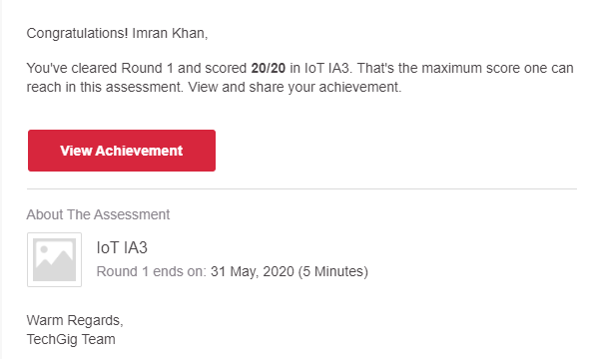

**Certification Course Details**:

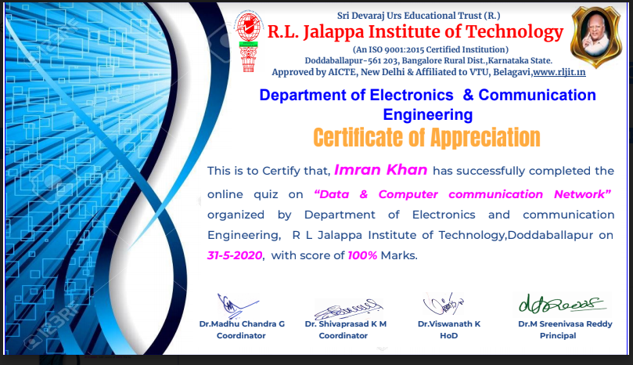

**Coding Challenges Details**:

**program1:**

|  |
| --- |
|  |
| n=int(input("Enter number:")) | |
|  | | temp=n |
|  | | rev=0 |
|  | | while(n>0): |
|  | | dig=n%10 |
|  | | rev=rev*10+dig |
|  | | n=n//10 |
|  | | if(temp==rev): |
|  | | print("The number is a palindrome!") |
|  | | else: |
|  | | print("The number isn't a palindrome!") |